Sponsorship Levels
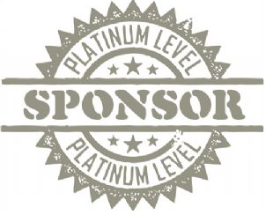
Platinum Sponsor: $5,500
♦ Name and logo on all print materials
♦ Name mention in TV advertisements
♦ Name, logo and web link on festival website
♦ 10X10 or 20X20 booth at festival
♦ Full page advertisement in festival Taster’s Guide
♦ 20 two day festival admissions

Gold Sponsor: $3,500
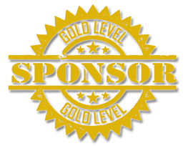
♦ Name and logo on all print materials
♦ Name mention in TV advertisements
♦ Name, logo and web link on festival web site
♦10X10 booth at festival
♦ Half page advertisement in festival Taster’s Guide
♦ 14 two day festival admissions

Silver Sponsor: $2,500
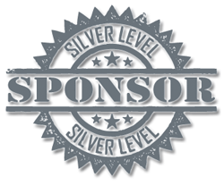
♦ Name and logo in all print materials
♦ Name, logo and web link on festival web site
♦ 10X10 booth at festival
♦ Quarter page advertisement in festival Taster’s Guide
♦ 10 two day festival admissions

Bronze Sponsor $1,500
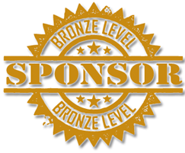
♦ Name and logo on all print materials
♦10X10 booth at festival
♦ Quarter page advertisement in festival Taster’s Guide
♦ 6 two day festival admissions

Specialty Sponsorships

Title Sponsor $15,000
♦ Your Company will present the Great Lakes Festival! Guests will see your name and logo all throughout the festival, as well as online and in all advertisements. 20X20 booth, as well as 20 two day passes are included.

Wrist Band Sponsor $2,000
♦ All attendees must be fitted with a wrist band when entering the festival. Your name and logo will be worn by each and every guest. 10X10 booth included.

Wine Glass Sponsor $4,000
♦ Guests will see your name and logo for years to come on this beautiful commemorative wine glass. 10X10 booth included.

Cloth Tote Bags $5,000
♦ Festival attendees will display your name and logo on these reusable cloth totes. 10X10 booth included.

Commemorative Pens $2,000
♦ Every guest needs a pen with them to take notes on all the fabulous products. Your name and logo will be in the hands of all attendees. 10X10 booth included.

Music Stage Sponsor $4,000
♦ All eyes will be on your name and logo as the bands rock the Music Stage all night! 10X10 booth included.

Food & Wine Stage Sponsor $4,000
♦ Chef Paul Mach and Ed Draves of the Premier Group will showcase your name and logo as they whip up some delicious dishes, paired with delectable wines. 10X10 booth included.

Email us with any questions or concerns: glfevents@greatlakesfestival.com
www.greatlakesfestival.com • 1 Park Place, Suite 233 Fredonia, NY 14063

